Activity 3.1: Debugging and Error Handling
Find and correct JavaScript errors using systematic troubleshooting.

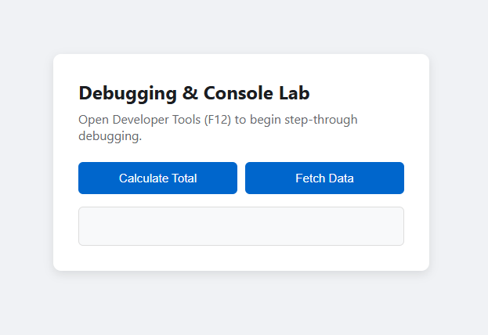
Browser console error
console.log(), console.warn() and console.error()
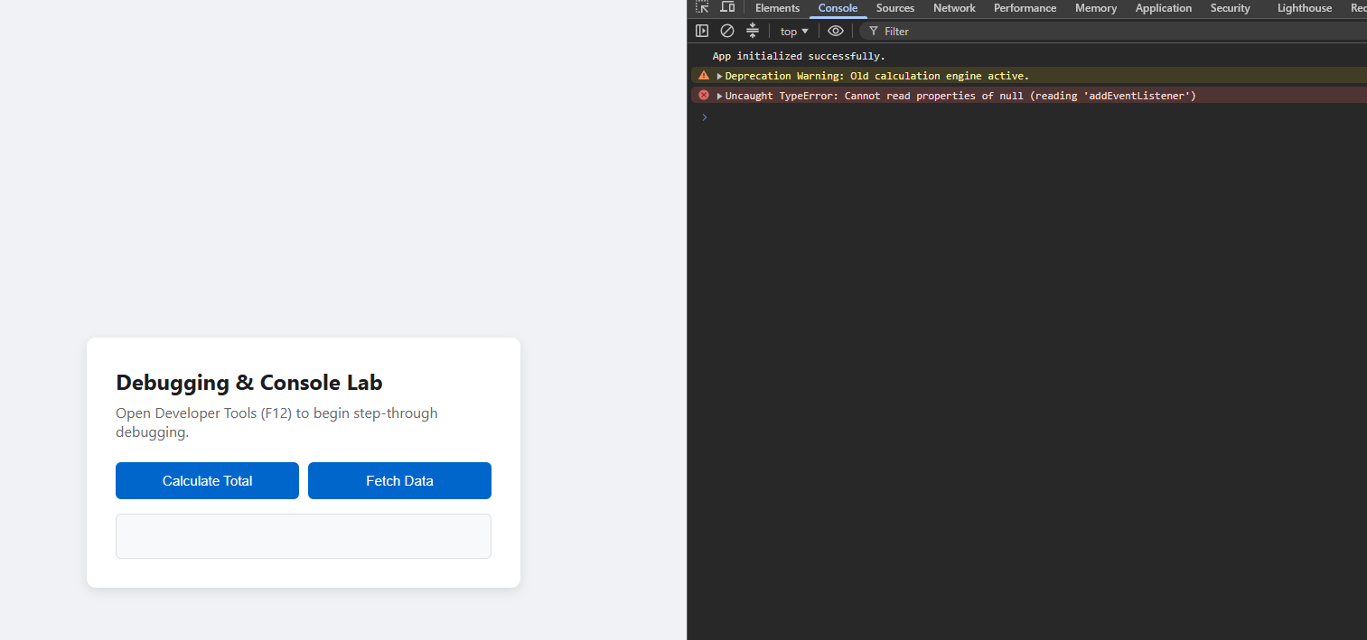
Breakpoint step through
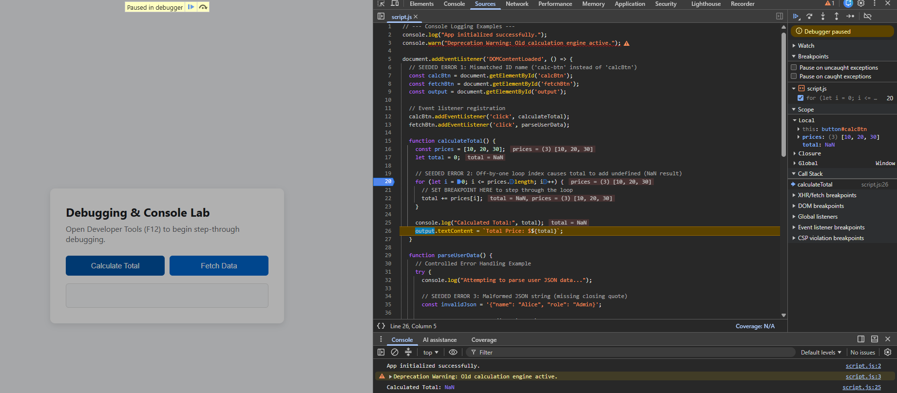
Seeded error 1
Before
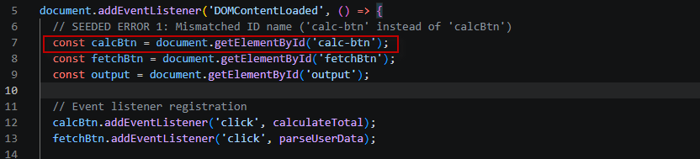
After
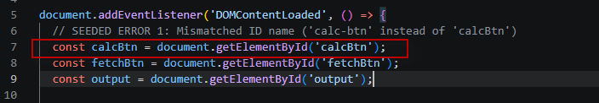

Seeded error 2
Before
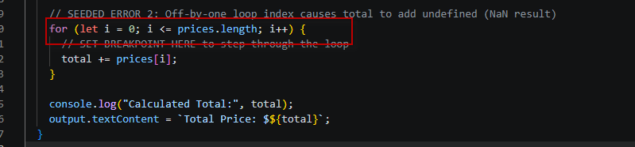
After
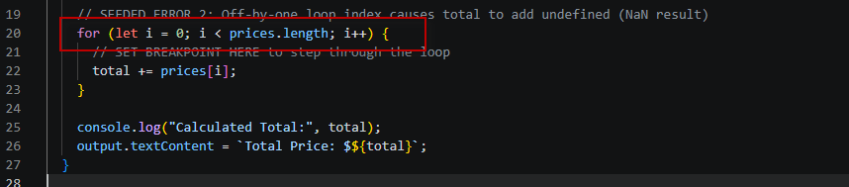
Seeded error 3
Before
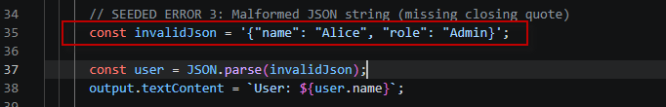
After
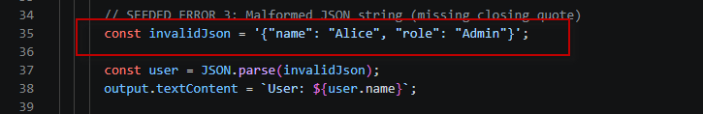

Catch try error
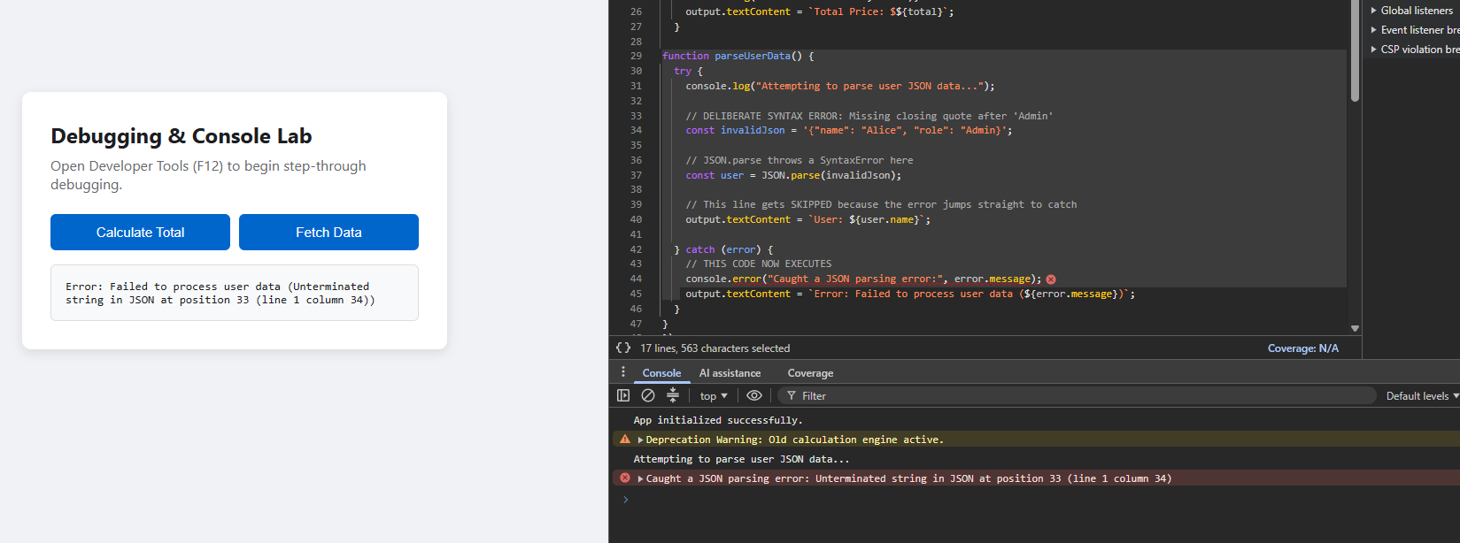
Fixed code
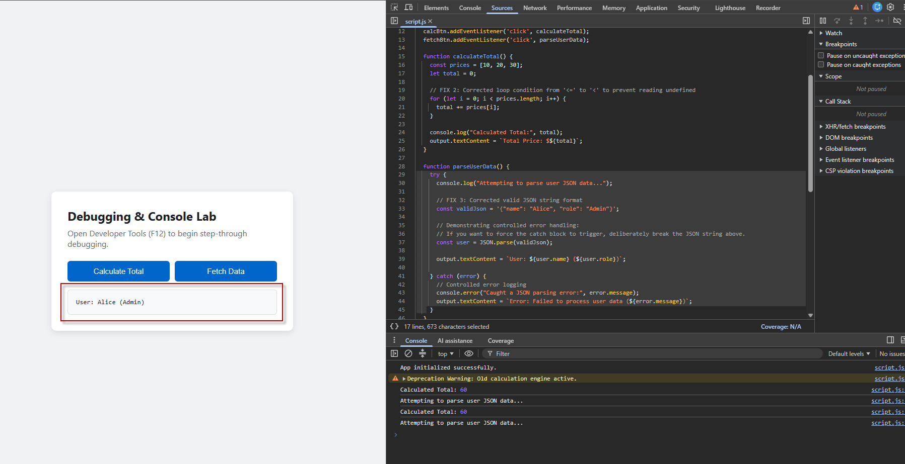

Activity 3.2: Department Contact Form with Validation
Create fields for name, department, email, issue category and message.
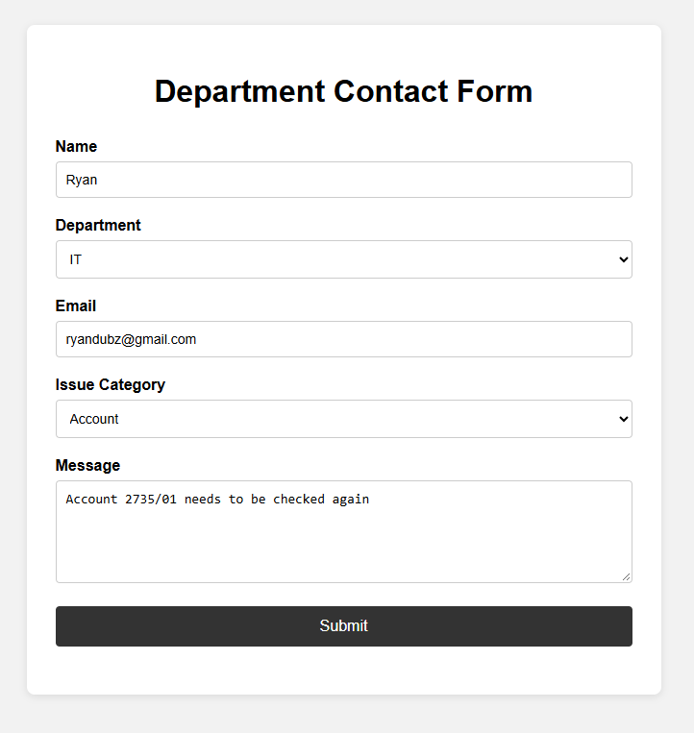
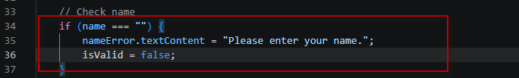
-----------

Prevent submission when something is missing
This is an important part of the assessment.
At the beginning of your submit event you have:
This prevents the browser from submitting/reloading the form while your JavaScript checks the information.
Then JavaScript checks every required field.
For example:
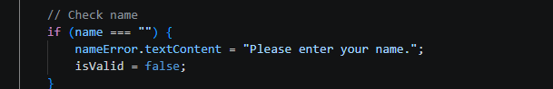
If any field is missing:
Therefore, the success message won't appear.
Assessment requirement
Prevent submission when required data is missing.
-----------
Check the email
The JavaScript also needs to check whether the email looks reasonable.
For example:
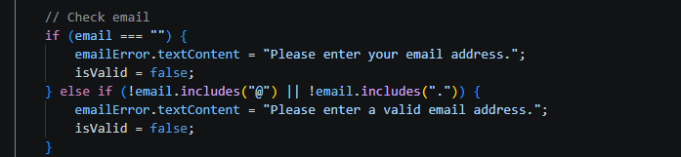
This gives you two situations.
Nothing entered
Email: [ ]
Please enter your email address.

Bad email
Email: [ryandubz@gmail.com]]
Please enter a valid email address.
Reasonable email
Email: [ryandubz@gmail.com]
This passes the basic check.
Check that the email format is reasonable.
-----------
Display specific error messages
This is where your HTML and JavaScript work together.
For example, your HTML has:
Then JavaScript changes it:
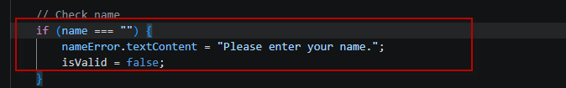So instead of just saying:
Error
the user gets a specific explanation.
You should have messages such as:
Problem | Message
Name missing | Please enter your name.
Department missing | Please select a department.
Email missing | Please enter your email address.
Email invalid | Please enter a valid email address.
Category missing | Please select an issue category.
Message missing | Please enter a message.
-----------
Use DOM methods
Your JavaScript must interact with the HTML.
You do this with:
For example:
This means JavaScript finds the HTML element with:
and gets its value.
You also use the DOM to change the error messages:
and:
nameError.textContent = "Please enter your name.";
By using document.getElementById() to access the form elements and textContent to update the error and success messages in the DOM.
-----------
Use a submit event listener
Your JavaScript should have:
This means:
When the user clicks Submit, run my validation code.
Then:
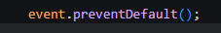
stops the normal form submission.

So, the process is:
User clicks Submit
↓
submit event occurs
↓
JavaScript runs
↓
Check all fields
↓
Check email
↓
Errors OR success
-----------
Display success for valid input
At the end of your validation you have:
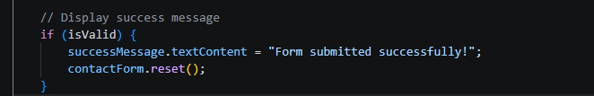This means:
If every field passed validation, show the success message.
The browser should display:
Form submitted successfully!
-----------

Test valid, invalid and boundary cases
First case test
Missing-field validation evidence
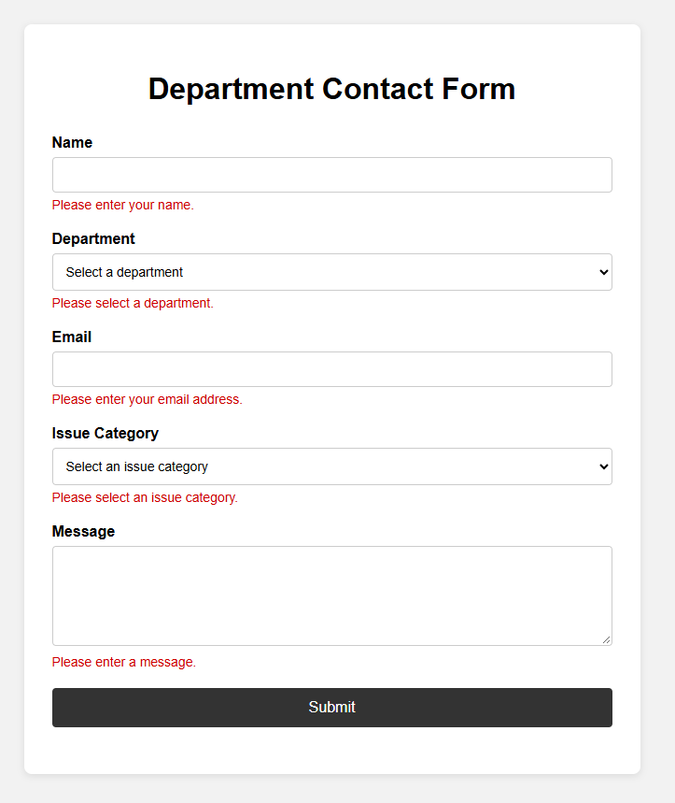
Test invalid email
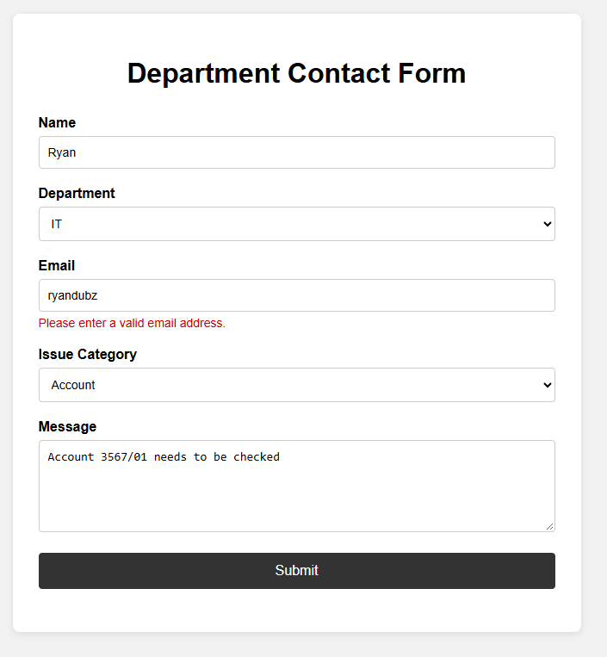

Test valid input
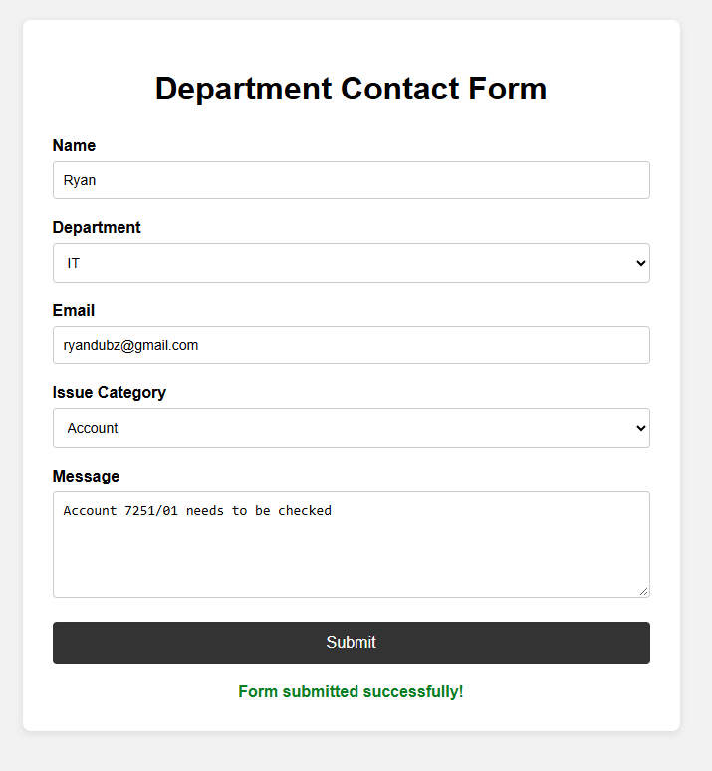
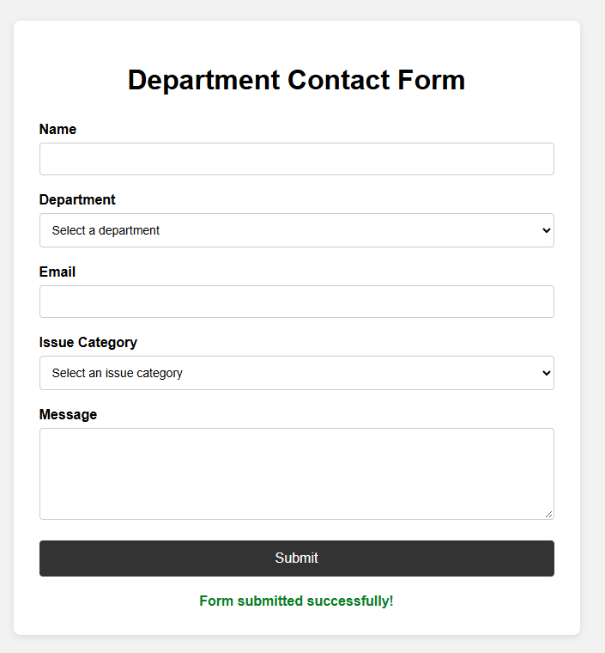

Test boundary cases
Boundary case 1:
Spaces name
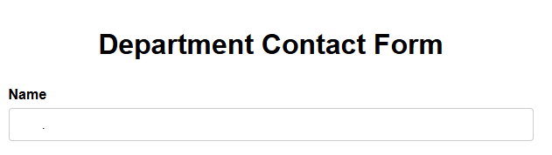

Boundary case 2:
Empty Spaces in messages
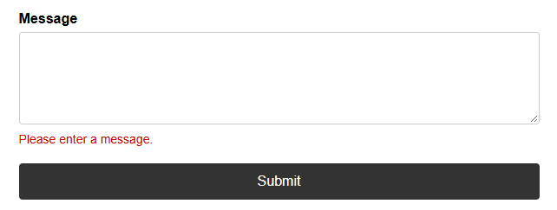
Boundary Case 3
Almost-valid email
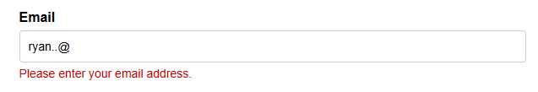

Valid email
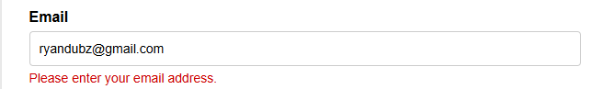
--------
Activity 3.3 DOM Manipulation and Events
Select elements by ID or query selector
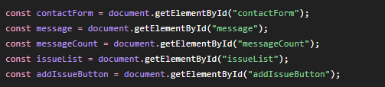
I used document.getElementById() to select specific HTML elements so JavaScript could interact with them.
----------
Add an issue list to the HTML
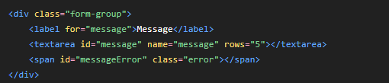
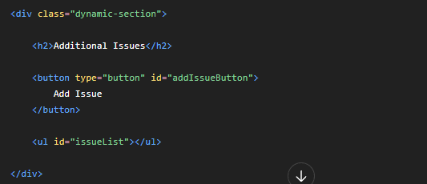
Additional Issues [ Add Issue ]
---------

Add a character counter
Original message
Should be changed to
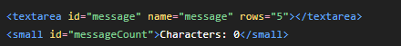
Now the page can dynamically show how many characters have been entered.
----------
Respond to an input event
This listens for the input event.
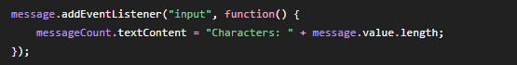
Every time you type something, JavaScript updates:
Characters: 0
to:
Characters: 1
then:
Characters: 2
and so on.

---------

Add an item dynamically
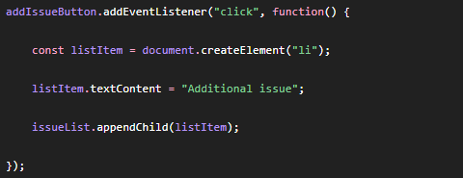
Now click:
Add Issue
The page changes to:
Additional Issues
[ Add Issue ]
• Additional issue
Click it again:
• Additional issue
• Additional issue
Click again:
• Additional issue
• Additional issue
• Additional issue
The items are being created dynamically using JavaScript.
---------

Add a Remove button
By replacing the old code with he below addIssueButton
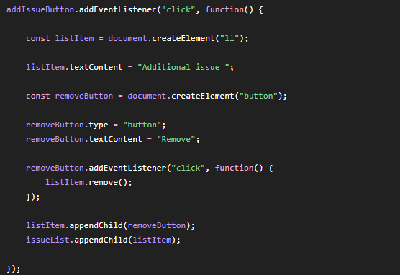
Now when you click:
Add Issue
you get:
• Additional issue [Remove]
Click Remove.
The item disappears.
--------

Add a change event
The below is already showing
The following will be added
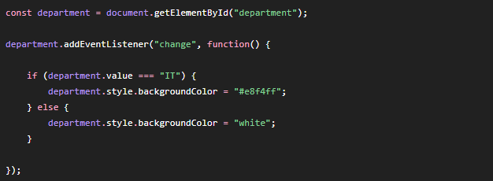
Now:
Before selecting IT
Normal dropdown.
Select IT
The dropdown changes style.
This demonstrates:
change event
and:
Change styles dynamically
---------

Change text dynamically
Currently showing
The following javascript will be added
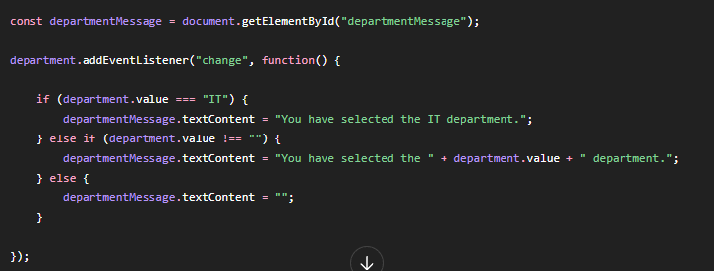
Now selecting:
IT
produces:
You have selected the IT department
Selecting:
Finance
produces:
You have selected the Finance department
That's another example of DOM manipulation
---------
Use event.preventDefault()
The following code is already showing
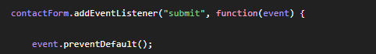
No need for more code
This satisfies:
Use event.preventDefault() where appropriate
---------

Keep the interface clear
The following code will be added to clean up the interface
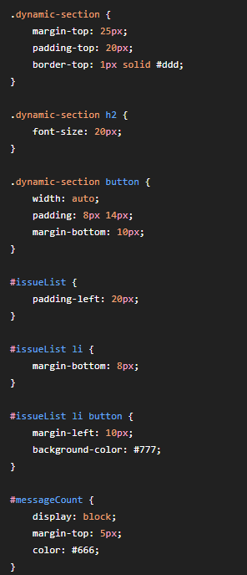
--------

What your JavaScript now demonstrates
Your JavaScript is now demonstrating several different concepts.
Selecting elements
Input event
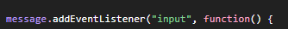
Change event
Click event
Creating an element
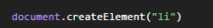
Adding an element
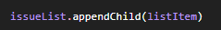
Removing an element
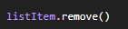
Changing text
Changing styles
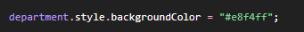
Preventing default behaviour
--------

DOM Selectors and Events Explanations
The application uses document.getElementById() to select specific HTML elements by their ID. These selectors allow JavaScript to access and update the form elements and dynamic content.
An input event is used on the message field to update the character count while the user types. A change event is used on the department dropdown to update the message and styling when the selected department changes. A click event is used on the Add Issue button to dynamically create and add a new item to the list.
Each dynamically created item has a Remove button. Clicking the Remove button removes the item from the page using the DOM remove() method.
The form also uses event.preventDefault() to prevent the normal browser submission while JavaScript processes the form.
Activity 3.4: Display Data from an API
Initially the data shows
API Data
[ Load API Data ]
When you click the button:
Loading data...
Then the API responds and your page displays something like:
API Data
User ID: 1
Name: Leanne Graham
Username: Bret
Email: Sincere@april.biz
--------

Add the API section to HTML
Originally the code was
The following will be added
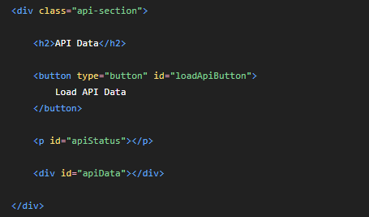
Your page will now have:
Department Contact Form
[Your existing form]
API Data
[ Load API Data ]
---------

Add CSS
The following CSS will be added
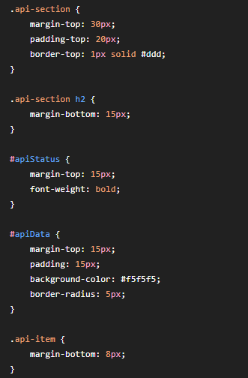
Which makes the API information easier to read
--------
Select the API elements
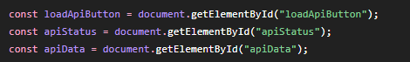
I am using the following
This satisfies the DOM-selection requirement
---------

Create the GET request
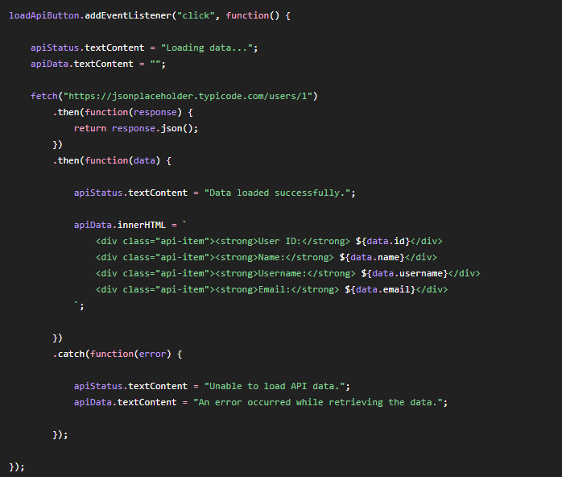
--------

What is fetch() doing?
sends a request to the API.
We're making a GET request because we're asking the API to give us information.
You don't have to manually write:
GET
because fetch() uses GET by default when no other method is specified.
So:
Your webpage
↓
fetch()
↓
Public API
↓
Response
----------

Convert the response to JSON
This sends a response to the API
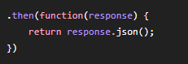
Receieves the response
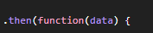
Now we can access fields such as:
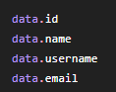
--------

Display selected fields
We're not displaying everything returned by the API.
We're selecting specific fields:
data.id
data.name
data.username
data.email
and putting them into the page:
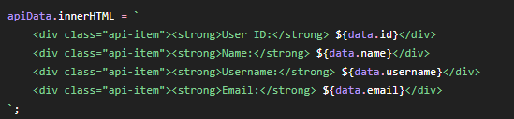
--------
Loading/status message
Before the request:
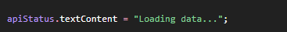
The user sees:
Loading data...
Once it succeeds:
The user sees:
Data loaded successfully.
---------

Error handling
This part is extremely important:
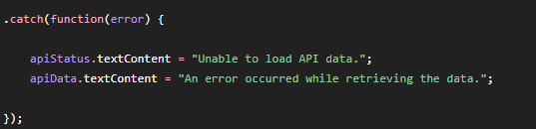
If something goes wrong, the page doesn't crash.
Instead, the user sees:
Unable to load API data.
and:
An error occurred while retrieving the data.
---------

Test the successful API request
Failed
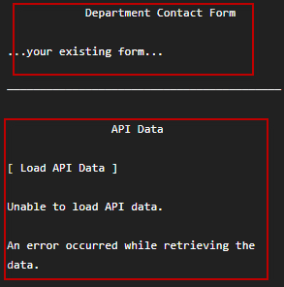
Successful
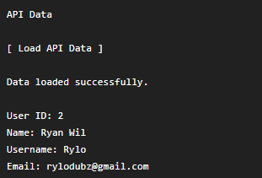
--------

Test the error handling
Proving the catch() works. The following file
will be changed to
However, depending on the test API, that may return a valid HTTP response rather than trigger catch(). So a more reliable simulated failure is to temporarily use an invalid domain:
Now click:
Load API Data
You should get:
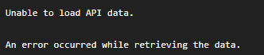
Restore the working API after
What is an API?
An API allows one application to communicate with another application and request or exchange data and follows the following flow
Your webpage
↓
API
↓
JSON data
↓
Your JavaScript
↓
Information displayed on webpage
---------

What is the request?
The request is:
Your webpage is asking the API:
Give me the information for user 2.
The webpage uses fetch() to send a GET request to a public API. The API returns information in JSON format. The response is converted into JavaScript data using response.json(), allowing selected fields such as the ID, name, username and email to be displayed on the webpage.
A loading message is displayed while the request is being processed. The code also uses .catch() to handle a failed request and display an error message instead of allowing the page to fail.
An API allows different applications to communicate with each other and exchange data. In this example, the webpage requests data from the public API and then displays selected information to the user.
----------
Confidential information requirement
The assessment specifically says:
Do not expose confidential credentials or customer information.
We're using a public test API.
You are not putting:
- passwords
- API keys
- customer records
- banking information
- private company credentials
into the code.

